Linux Environment Variable Assignment

- State the command for the following.
  - view current environment variables
    - env
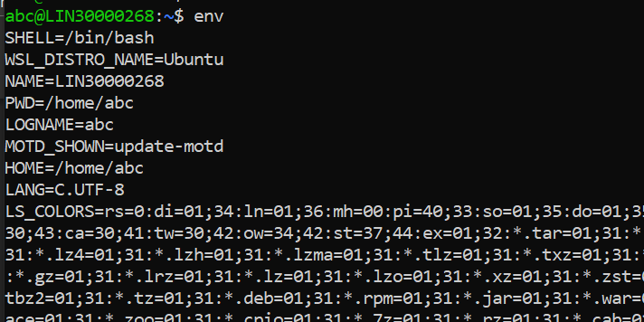
  - display the PATH evirnment variable value
    - echo $PATH
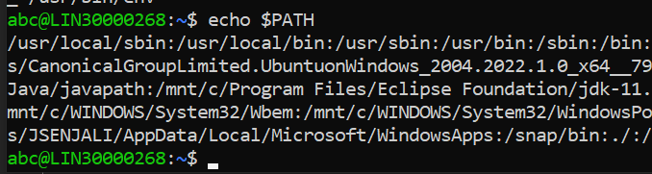
  - update PATH to include the path to your home directory
    - PATH=$PATH:$HOME
- How will you make the environment changes applicable to all users? Which script is to be modified?
    - .prifile file
- I have installed an application named “myapp”. After installation, if I invoke the application, it fails with error as “Command myapp not found”. How will you fix this?

